DOCUMENT 03 — VATS Technical Architecture (7 layers)
Visionary Internal · v1.0 · Visionary Adaptive Teaching System.

VATS is WHAT the intelligence does. (AIRA, Doc 05, is HOW it runs in production.)

1. The seven layers
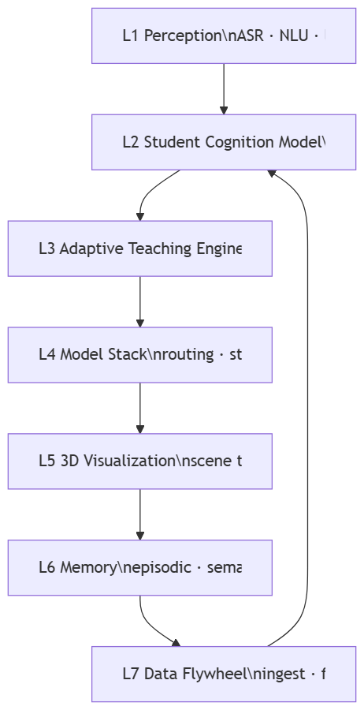

2. Layer notes
- L2 SCM: Bayesian Knowledge Tracing per concept: P(mastered), p_guess, p_slip,
p_transit. Zone of Proximal Development target band [0.35, 0.75] — teach inside it.
Prerequisite trace returns the ROOT-cause gap, not the symptom.
- L3 ATE: selects pedagogy (visual / analogy / worked-example / Socratic) from SCM +
error class; runs the comprehension-verification loop (no concept marked taught until
the check passes).
- L4 Model Stack: Phase1 DeepSeek-R1 + Gemma-3 (API) → Phase2 QLoRA fine-tune →
Phase3 proprietary. Hallucination guard = NLI claim-check vs curriculum corpus.
- L5 3D: [SCENE:…] tokens; Draco-compressed glTF; LOD; SVG 2D fallback on <3GB RAM.
- L6 Memory: short-term Redis, episodic+semantic Qdrant, procedural SCM Postgres.
- L7 Flywheel: log from user #1; quality-filter; teacher-reviewed 5%; weekly SFT/DPO.

3. Latency & device budget (p95, 4G, ₹8k Android)
TTFT ≤200ms · 3D first-frame ≤1.5s · 30fps · offline for started lessons · bundle split
per app · fonts subset per script.

4. Practice doctrine
Socratic hints, never reveal the answer. Wrong → diagnose error class → re-teach with a
DIFFERENT example → one similar question → update SCM.

OKF
KF1: BKT update <100ms post-response. KF2: comprehension loop blocks unverified "taught."
KF3: hallucination <0.5% on NCERT benchmark. KF4: TTFT ≤200ms on 4G. KF5: ZPD band respected
in 100% of difficulty selections.

